Requests

One finger: new pencil or sharpen pencil
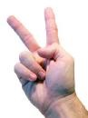
Two fingers: restroom

Three fingers: tissues

Four fingers: throw trash away

Five fingers: question or comment

